Er RAJAT KALIA
(B.TECH IIT-Delhi)
PH. 9815439805
Er MANISH KALIA
B.TECH (Delhi COLLEGE OF ENGINEERING)
PH. 09990074601,9878146388

9DE

Definition:-
We define log as, a^{y} = x than y = log_{a}x. in log_{a}x. both x and a are positive ie. x > 0 and a > 0 and also a 1.
Dumb Question:- Why a cannot be 1 ?
Ans:- Suppose a is 1 then let us attempt to y such that y = log₁x.
Now according to definition of log.
1^{y} = x.
But no matter what power we raise to 1 the answer will be. 1 only so we will never never be able to find y.
Hence a cannot be 1.
Some important formulae:- (Formulaes marked with * are important. This is not be printed)
1. log_{a}a = 1.
2. log_{any}1 = 0.
3. log_{c}a = log_{b}a.log_{c}b.
Why ?
Let log_{b}a = x and log_{c}b = y
So, by definition, a = b^{x} ..................................... (i)
b = c^{y} ...................................... (ii)
Using (i) & (ii) a = c^{xy}
Now taking log on both sides.
log_{c}a = xy
log_{b}a.log_{c}b.
Illustration - 1.
Find value of log₂10.log₁₀2 ?
Using formula 3 we get.
log₂10.log₁₀2 = log₁₀10
Now using formula 1 we get
log₁₀10 = 1
Hence log₂10.log₁₀2 = 1
4. log_{a}(m.n) = log_{a}m + log_{a}n
Why ?
Let log_{a}m = x
log_{a}n = y
So, m = a^{x} and n = a^{y} [Using definition]
m.n = a^{x}.a^{y} = a^{x + y}
=> log_{a}(mn) = log_{a}a^{x + y}
= x + y
= log_{a}m + log_{a}n.

5. log_{a}(m/n) = log_{a}m - log_{a}n
Why ?
Let log_{a}m = x
log_{a}n = y
m = a^{x} and n = a^{y} [Using definition]
m/n = a^{x}/a^{y} = a^{x - y}
=> log_{a}m/n = x - y
= log_{a}m - log_{a}n
6. log_{a}m^{n} = n log_{a}m.
why ?
Let log_{a}m^{n} = y
By definition a^{y} = m^{n}
or, a^{y/x} = m
Again using definition of log
log_{a}m = y/x
or n log_{a}m = y
so, log_{a}m^{n} = n log_{a}m.
Illustration - 2. If log₁₂27 = a, then log₃16 = ??
log₃16 = log₃2⁴ = 4 log₃2 ............................................... (i)
Now, log₁₂27 = log₁₂3³
= 3 log₁₂3
= 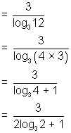
So, log₃2 = 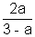
Now, log₃ = 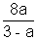
*7. log = log_{a}n
log = p log_{a}q^{n} - (Using formula 6.)
= p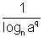 - (Using formula 3.)
= 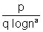- (Using formula 6.)
= 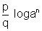- (Using formula 3.)
*8. = n
Illustration - 3.
Evaluate.
= (Using formula 7)
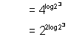
(Using formula 6)
= 9 (using formula 8)
Hence = 9
log_{p}a > log_{p}b
=> a b if p is greater than 1 i.e. p > 1
or b a if p is positive and less than 1, 0 < p < 1
Remembering Tip:- If base if > 1 then inequality remains same and if base is + ve but less than 1 then sign of inequality is reversed.
Why ?
Let log_{p}a = x
log_{p}b = y
So, a = p^{x}
and b = p^{y}
Now x > y is given
So, if p > 1
then a b
and if 0 < p < 1
then a b

Illustration - 4.
If log_{0.2}(x - 1) < log_{0.4}(x - 1) then x lies interval.
Now, log_{0.2}(x - 1) <
=> log_{0.2}(x - 1) < log_{0.2}(x - 1)
=> log_{0.2}(x - 1) < 0
or, log_{0.2}(x - 1) < 0 = log_{0.2}1
Since 0.2 is less than 1 so, x - 1 > 1 or x > 2
log - flow Questions
Easy
Q1. Find the value of log₈128 ?
Ans:- log₈128 =
= log₂2
=
Q2. What is the approx vaslue of log₁9.903 ?
Ans:- The value does not exist because the base of a logarithm cannot be 1.
Q3. Find solution of the equation 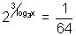?
Ans:- = 2⁻ ⁶
So, 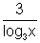= - 6
- = log₃x
So, x =
Q4. Find equation log_{e}x + log_{e}(1 + x) = 0 free from log ?
Ans:- log_{e}x + log_{e}(1 + x) = 0
=> log_{e}(x(1 + x)) = 0
So, x(1 + x) = 1
or, x² + x + 1 = 0
Q5. If log₂x X log₂ + 4 = 0 then find the value of x.
Ans:- log₂x X (log₂x - log₂16) + 4 = 0
=> (log₂x)² - 4 log₂2 log₂x + 4 = 0
=> (log₂x)² - 4 log₂2 + 4 = 0
=> (log₂x - 2)² = 0
=> log₂x = 2
or, x = 4.
Q6. If 2 log₈N = p, log₂2N = q and q - p = 4 then find the value of N ?
Ans:- p = 2 log₈N
= log₂N
q = log₂2N
= log₂2 + log₂N
= 1 + log₂N
q - p = 1 + log₂ N - log₂N
= 1 + log₂N = 4 (Given)
So, log₂N = 9
0r N = 2⁹ = 512
Q7. If a, b, c are consecutive positive integrals and log(1 + ac) = 2K then find value of K ?
Ans:- Let a = n
b = n + 1
c = n + 2
So, log(1 + ac) = log(1 + n(n + 2))
= log(1 + n² + 2n)
= log(n + 1)²
= 2 log(n + 1)
= 2 logb
Value of K is logb.
Q8. Find value of x if log₃x.log_{y}3.log₂y = 5 ?
Ans:- log₃x.log_{y}3.log₂y = log₃x.log₂3
= log₂x
= 5 (Given)
So, x = 2⁵ = 32.
Q9. The value of e^{ln(ln 7)} IS 7, True or false.
Ans:- e^{ln(ln 7)} = ln 7^{ln e}
= ln 7
So, it is false.

Q10. The value of 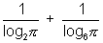is greater then 2. true or false ?
Ans:- 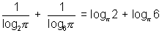
=
Now, 12 > ²
So,
or > 2
So, It is true.
Logarithms - flow Questions
Medium
Q1. If a, b, c are distinct positive numbers each different from 1 such that
[log_{b}a log_{c}a - log_{a}a] + [log_{a}b log_{c}b - log_{b}b] + [log_{a}c log_{b}c - log_{c}c] = 0 then find the value of abc ?
Ans:- Let us change all logarithms to base
So, the eq^{n} now becomes
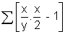= 0 where x = etc.
So, 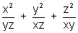= 3
or, x³ + y³ + z³ - 3xyz = 0
or, (x + y + z)(x² + y² + z² - xy - yz - zx) = 0
Since we have, x² + y² + z² - xy - yz - zx = [(x - y)² + (y - z)² + (z - x)²] 0
** Tip: Writing x² + y² + z² - xy - yz - zx as [(x - y)² + (y - z)² + (z - x)²] which is non-negative for real x, y, z is an useful magnipulation is solving many questions.
So, we calculate x + y + z = 0 that is
= 0
or, = 0
or, abc = 1
Dumb Question:- Why x² + y² + z² - xy - yz - zx is not equal to 0 ?
Ans:- x² + y² + z² - xy - yz - zx = [(x - y)² + (y - z)² + (z - x)²]
Now since it is given in question that x, y, z are distinct positive numbers, this cannot be equal to zero.
Q2. If log_{a}(ab) = x, then find value of log_{b}(ab) ?
Ans:- log_{a}(ab) = log_{a}a + log_{a}b = 1 + log_{a}b = x
So, log_{a}b = x - 1
or log_{b}a = 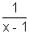
or, log_{b}a + log_{b}b = + 1
=> log_{b}(ab) = 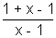
= 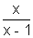
Q3. Find the least value of the expression
2 log₁₀x - log_{x}(0.01) for x > 1
Ans:- 2log₁₀x = log_{x}(0.01)
= 2 log₁₀ x - log_{x}10⁻²
= 2(log₁₀x + log_{x}10)
= 2(log₁₀x + 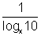)
= 2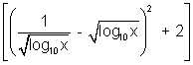
= 2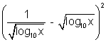 + 4
So, the minimum value is 4

Dumb Question:- How does log₁₀x + 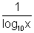was equated to + 2 ?
Ans:- log₁₀x + = 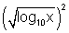+ 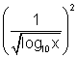- 2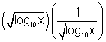 + 2
= + 2
Since x is given to be > 1. So, log₁₀x is a positive no.
Q4. Solve log_{2x + 3}(6x² + 23x + 21) = 4 - log_{3x + 7}(4x² + 12x + 9)
Ans:- log_{2x + 3}(6x² + 23x + 21) = 4 - log_{3x + 7}(4x² + 12x + 9)
=> log_{2x + 3}[(2x + 3)(3x + 7)] = 4 - log_{3x + 7}(2x + 3)²
=> 1 + log_{2x + 3}(3x + 7) = 4 - 2 log_{3x + 7}(2x + 3)
log_{2x + 3}(3x + 7) = 3 - 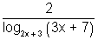
Let log_{2x + 3}(3x + 7) = y
y = 3 -
y² - 3y + 2 = 0
=> (y - 1)(y - 2) = 0
So, y = 1, y = 2
So, log_{2x + 3}(3x + 7) = 1
=> 3x + 7 = 2x + 3
=> x = - 4
But, this means that 2x + 3 = - 5 is a -ve value and base cannot be -ve. So, y = 1 is ruled out.
So, Now let us test y = 2
log_{2x + 3}(3x + 7) = 2
=> (2x + 3)² = 3x + 7
4x² + 12x + 9 - 3x - 7 = 0
4x² + 9x + 2 = 0
=> x = - 2, -
Following similar argument as above x = -2 is rule out, So, the final solution is x = -
Dumb Question:- Why x = -2 sol^{n} was ruled out ?
Ans:- If x = -2 then 2x + 3 = -1.
Again, the base cannot be a -ve no, so x = -2 is ruled out.
**Tip :- Never obtain a sol^{n} and believe it is a solution, always try and cross check or other way could be that you write conditions which sol^{n} should satisfy while solving the question itself definitely - a cleaner aproach.
Q5. Find the value of x satisfying the equation.
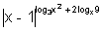= (x - 1)⁷ ?
Ans:- L.H.S. is a positive no being an exponential.
So, R.H.S. should also be +ve.
R.H.S. will be +ve if x > 1 and in that case |x - 1| = x - 1.
Hence, we can write given eq^{n} as
= (x - 1)⁷
This gives log₃x² - 2 log_{x}9 = 7
Now if log₃x = y, then eq^{n} reduces to
2y - = 7
or, 2y² - 7y - 4 = 0
or, y = 4, -
or, log₃x = 4, -
=> x = 3⁴, 3 ⁻
Since x > 1 so, x = 3 ^{- is rejected.}
^{Hence x = 81}

Dumb Question:- Why would R.H.S. be positive only if x > 1 ?
Ans:- R.H.S. is (x - 1)⁷
Now suppose if x < 1 then we have (-ve no) odd number.
Now let us explain this with an example say (- 2)⁷ = - 128 which is - ve.
So, clearly R.H.S. will be +ve only if x > 1.
HARD
Q1. If n is a natural no such that n = and P₁, P₂,.....P_{K} are distinct primes then show that logn > Klog2.
Ans:- Since n is a natural no and P₁, P₂ ......... P_{K} are prime nos, so, a₁, a₂ ....... a_{K} have to be natural nos.
So, a_{i} ...... 1 for ie. 1, 2, ............. K
Now logn = a₁logP₁ + a₂logP₂ + .................. + a_{K} logP_{K}
logP₁ + logP₂ + ..................... + logP_{n}
Now, since P₁, P₂ .................... P_{K} are distinct primes.
So, P_{i} 2 for i.e. 1, 2, ................. K.
So, logP_{i} > log2
Hence logn log2 + log2 + .................... + log2 = K log2
Hence logn K log2
Dumb Questions:- Why a₁, a₂, .................... a_{K} are natural no.
Ans:- Suppose a₁, ........... a_{K} - ve no.
than we will have a denominator will not be able to cancel with numerator because the prime nos do not cancel each other. Also if the a_{i} will be an irrational no so again n cannot be natural no.
Q2. Prove that
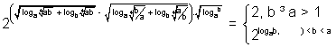
Ans:- Since 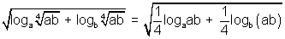
= 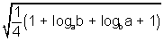
= 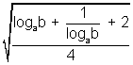
= 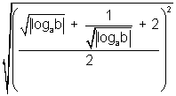
= 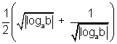
& 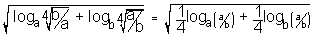
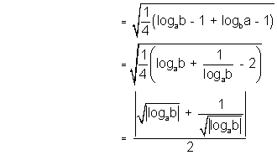
So, 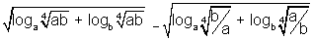= R (say)
So, R = 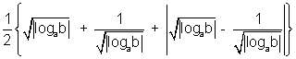
Case I: If b a 1
then P = 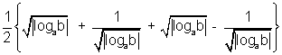
= 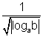
So, = 2¹ = 2
Case II: If 1 < b < a
then P =
=
Keywords
1. Log
2. Logarithm
3. Exponential

